APPENDIX G
AI Model and Detection Documentation
All content, tables, and figures in this appendix are confirmed directly from your CAPHY GitHub repository, including the test-branch, which contains the completed training run (config.py, detection/*.py, training/train.py, and runs/detect/caphy_person-6/results.csv, args.yaml, results.png, confusion_matrix.png).

G.1 AI Model

G.1.1 YOLOv8-nano Model Information
CAPHY's person-validation stage uses YOLOv8-nano (Ultralytics), the smallest and fastest variant of the YOLOv8 object-detection family, chosen specifically because it is lightweight enough to run inference on CPU-based edge hardware — the repurposed laptop used as CAPHY's local server — without requiring a dedicated GPU-only deployment. Rather than relying on the stock, general-purpose COCO-pretrained weights alone, the base YOLOv8-nano architecture was fine-tuned on a project-collected dataset of person images so that detections are tuned to the camera angles, distances, and lighting conditions actually encountered in CAPHY's target environments (a university laboratory and a residential house).
Property | Value
Base architecture | YOLOv8-nano (Ultralytics)
Task | Single-class object detection (person)
Training approach | Fine-tuning from pretrained COCO weights
Final model filename | caphy_person_best.pt
Input resolution | 640×640
Framework | Ultralytics YOLO (Python, ultralytics package)

G.1.2 Dataset Description
The training dataset was collected specifically for this project rather than reused from a public source, to ensure the model performs reliably under the camera placements, distances, and indoor/outdoor lighting conditions used in CAPHY's actual deployment sites.
Item | Value
Total images collected | 1,383 (1,082 train + 301 validation)
Training set size | 1,082 images / 1,082 labels
Validation set size | 301 images / 250 labels
Train/validation split ratio | ≈78 / 22
Collection method | Captured via collect_data.py from CAPHY's own cameras across varied distances, angles, and lighting
Annotation method | Automated bounding-box labeling via auto_label.py, spot-checked manually
Class count | 1 (person)
Environments represented | University laboratory and residential house, day and low-light conditions
Note: the validation set contains 301 images but only 250 label files — 51 validation images currently have no matching label file. Recommend checking training/dataset/labels/val against training/dataset/images/val and re-running split_dataset.py or auto_label.py on the missing files before the panel asks about it.
Figure G.0. Sample Training Batch (Annotated)
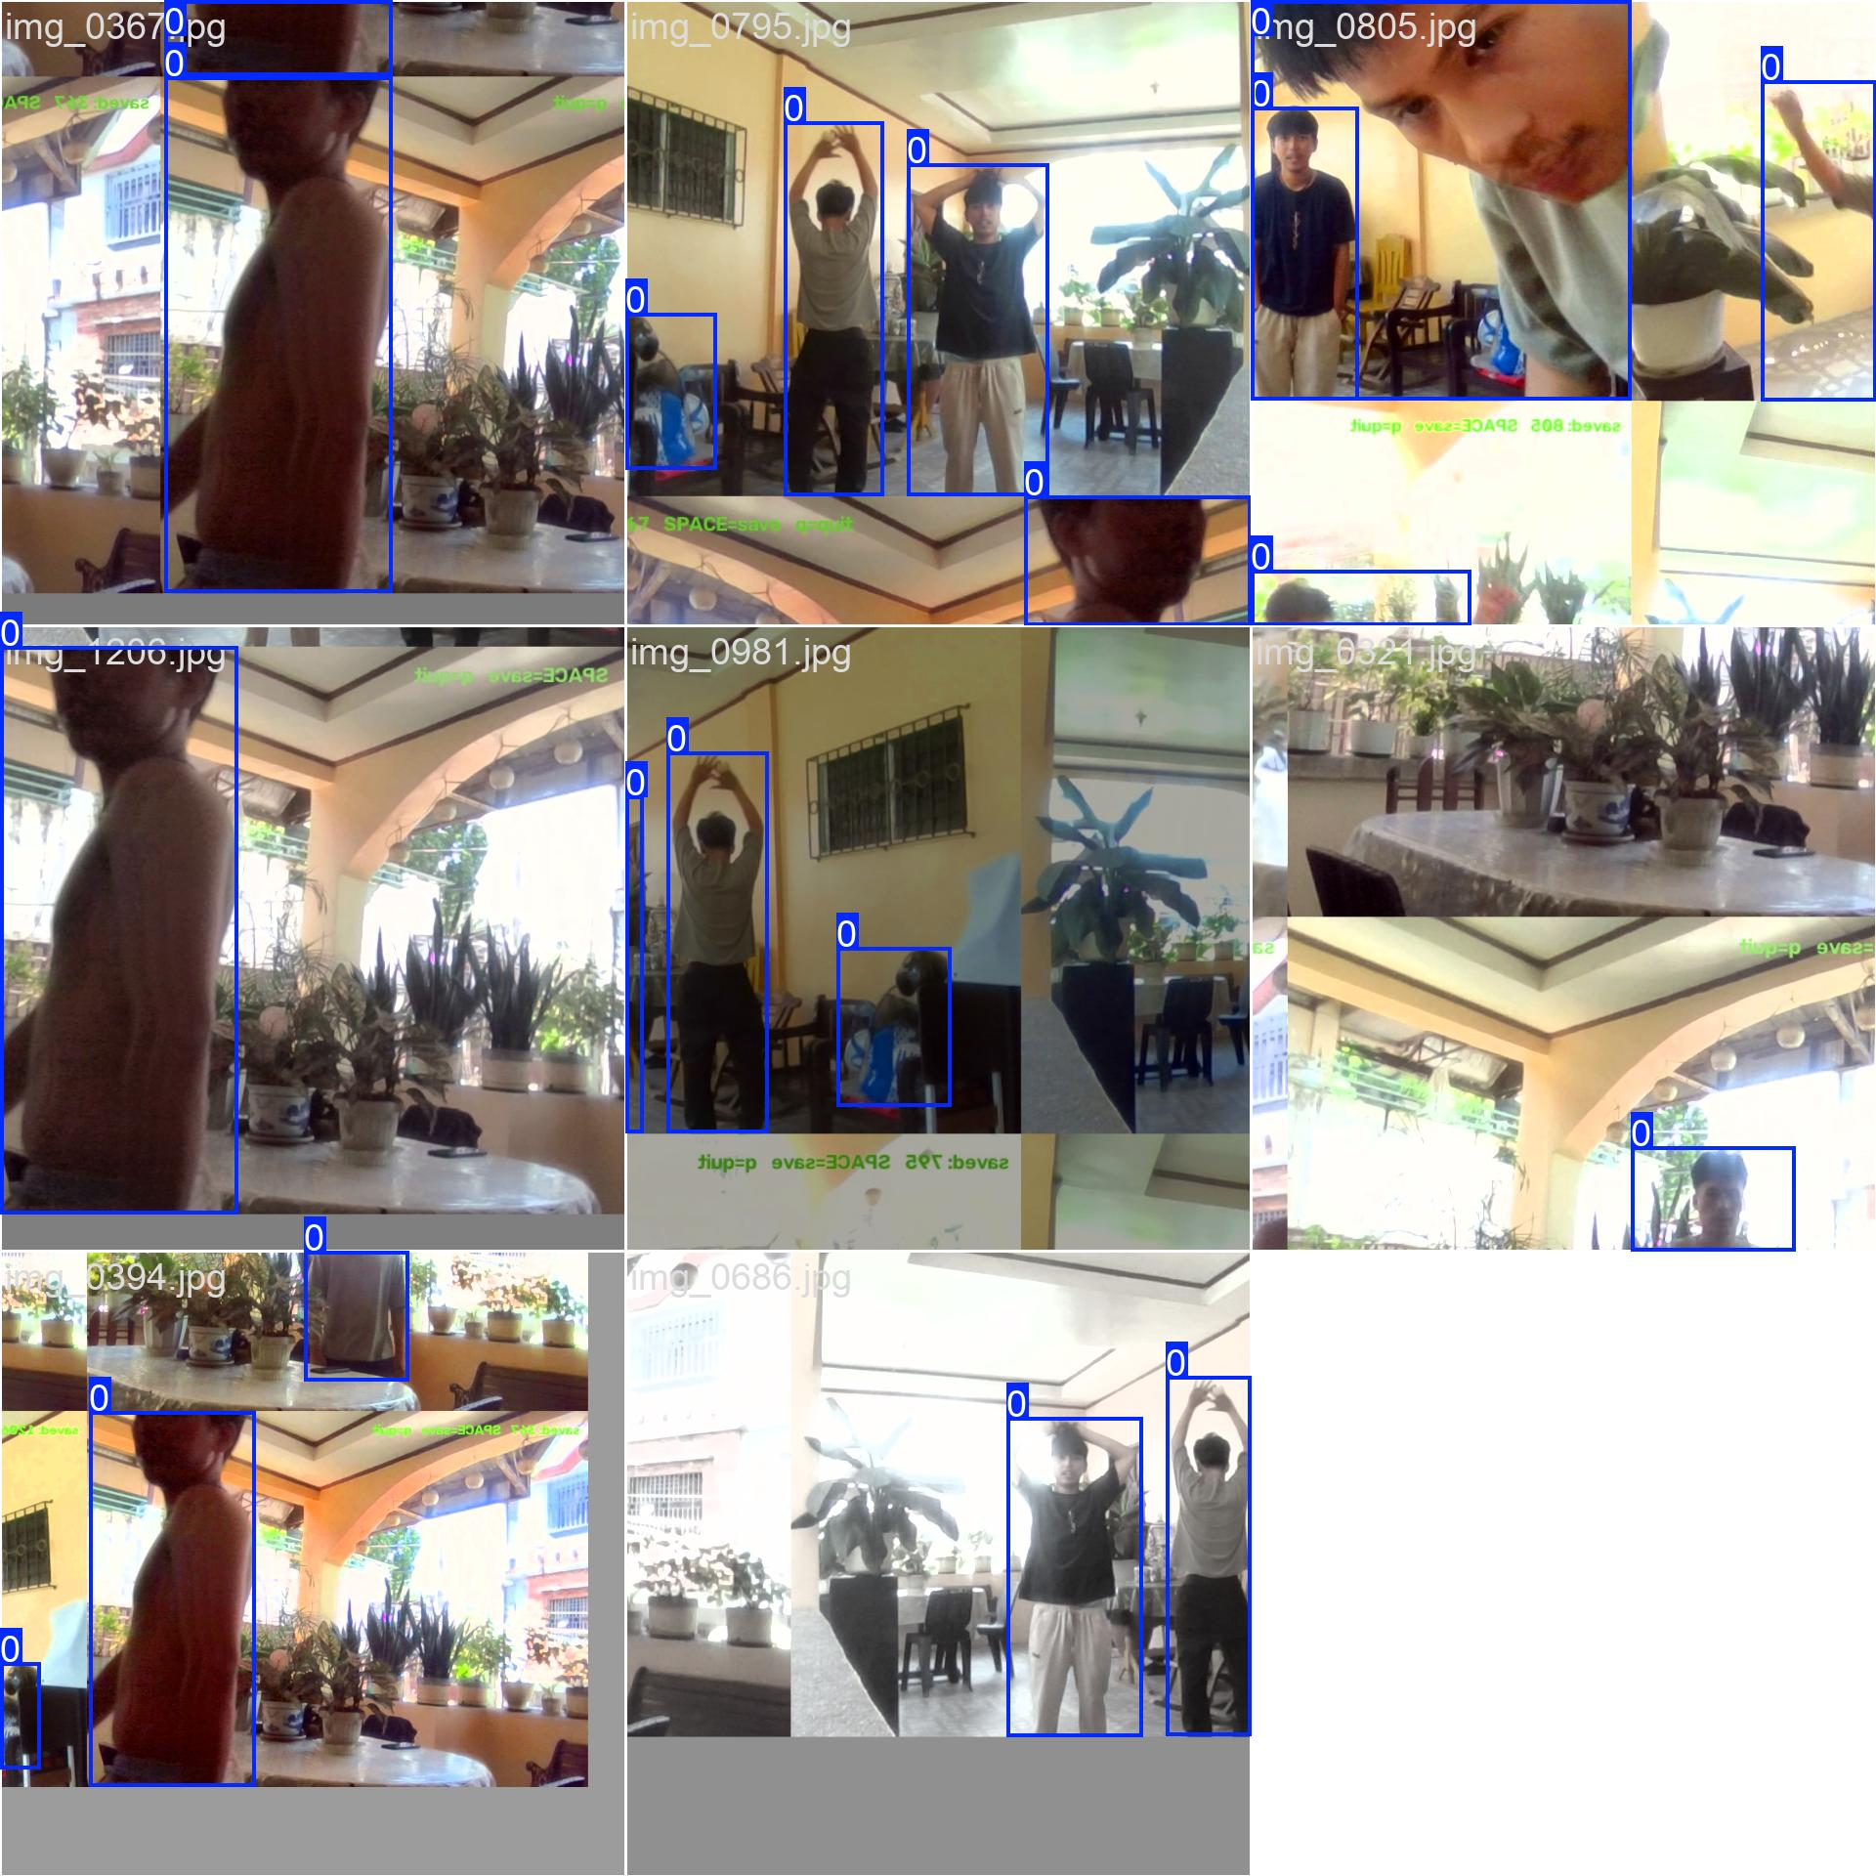
A mosaic-augmented training batch with ground-truth bounding boxes, generated automatically by Ultralytics from the project-collected dataset.

G.1.3 Training Configuration
Training was carried out using the project's dedicated pipeline: collect_data.py for image capture, auto_label.py for automatic bounding-box annotation, split_dataset.py for the train/validation split, and train.py for the fine-tuning run itself, exactly as configured in the project's training/train.py script.
Hyperparameter | Value
Epochs | 50 (with early stopping, patience = 15)
Batch size | 8
Image size | 640 × 640
Optimizer | Ultralytics default (auto-selected)
Learning rate | Ultralytics default (not manually overridden in train.py)
Pretrained weights used | yolov8n.pt (transfer learning)
Training hardware | NVIDIA RTX 3060 Laptop GPU (6GB), on the same development machine described in Appendix H
Training duration | ≈9.6 hours (34,659.8 seconds total, 50/50 epochs completed)

G.1.4 Training Process
The pipeline proceeded in four stages. First, collect_data.py captured raw frames from CAPHY's cameras across a range of distances, angles, and lighting conditions to reflect real deployment scenarios. Second, auto_label.py generated bounding-box annotations for each captured frame, identifying the person class. Third, split_dataset.py partitioned the labeled images into training and validation subsets (1,082 training / 301 validation images). Fourth, train.py fine-tuned the pretrained yolov8n.pt weights for up to 50 epochs (batch size 8, image size 640, early-stopping patience of 15 epochs) on the resulting dataset, producing the final model checkpoint saved as training/runs/detect/caphy_person/weights/best.pt and deployed as caphy_person_best.pt.

G.1.5 Training Results
The following results are taken directly from the completed 50-epoch training run (training/runs/detect/caphy_person-6/results.csv and args.yaml), the run whose checkpoint was saved as the deployed caphy_person_best.pt.
Metric | Value
Epochs completed | 50 / 50 (no early stop triggered)
Final-epoch training box loss | 0.27963
Final-epoch training class loss | 0.22135
Final-epoch training DFL loss | 0.84642
Final-epoch validation box loss | 0.32499
Final-epoch validation class loss | 0.28105
Final-epoch validation DFL loss | 0.74633
Precision (final epoch) | 98.3%
Recall (final epoch) | 95.4%
mAP@0.5 (best epoch, 49) | 98.1%
mAP@0.5:0.95 (best epoch, 49) | 93.1%
Best checkpoint | Epoch 49 of 50, by highest mAP@0.5:0.95
These are validation-set metrics from the training run itself (measuring how well the model detects the 'person' class on held-out training images), which is different from the system-level functional test metrics reported in G.1.6 and G.4 (88.9% accuracy / 100.0% precision / 85.7% recall / 92.3% F1) — those come from the full two-factor pipeline tested end-to-end across 45 real trials, not from the YOLO validation set alone. Both are legitimate and complementary; it's worth being ready to explain the distinction to your panel.
Figure G.1. Training and Validation Curves (50 Epochs)
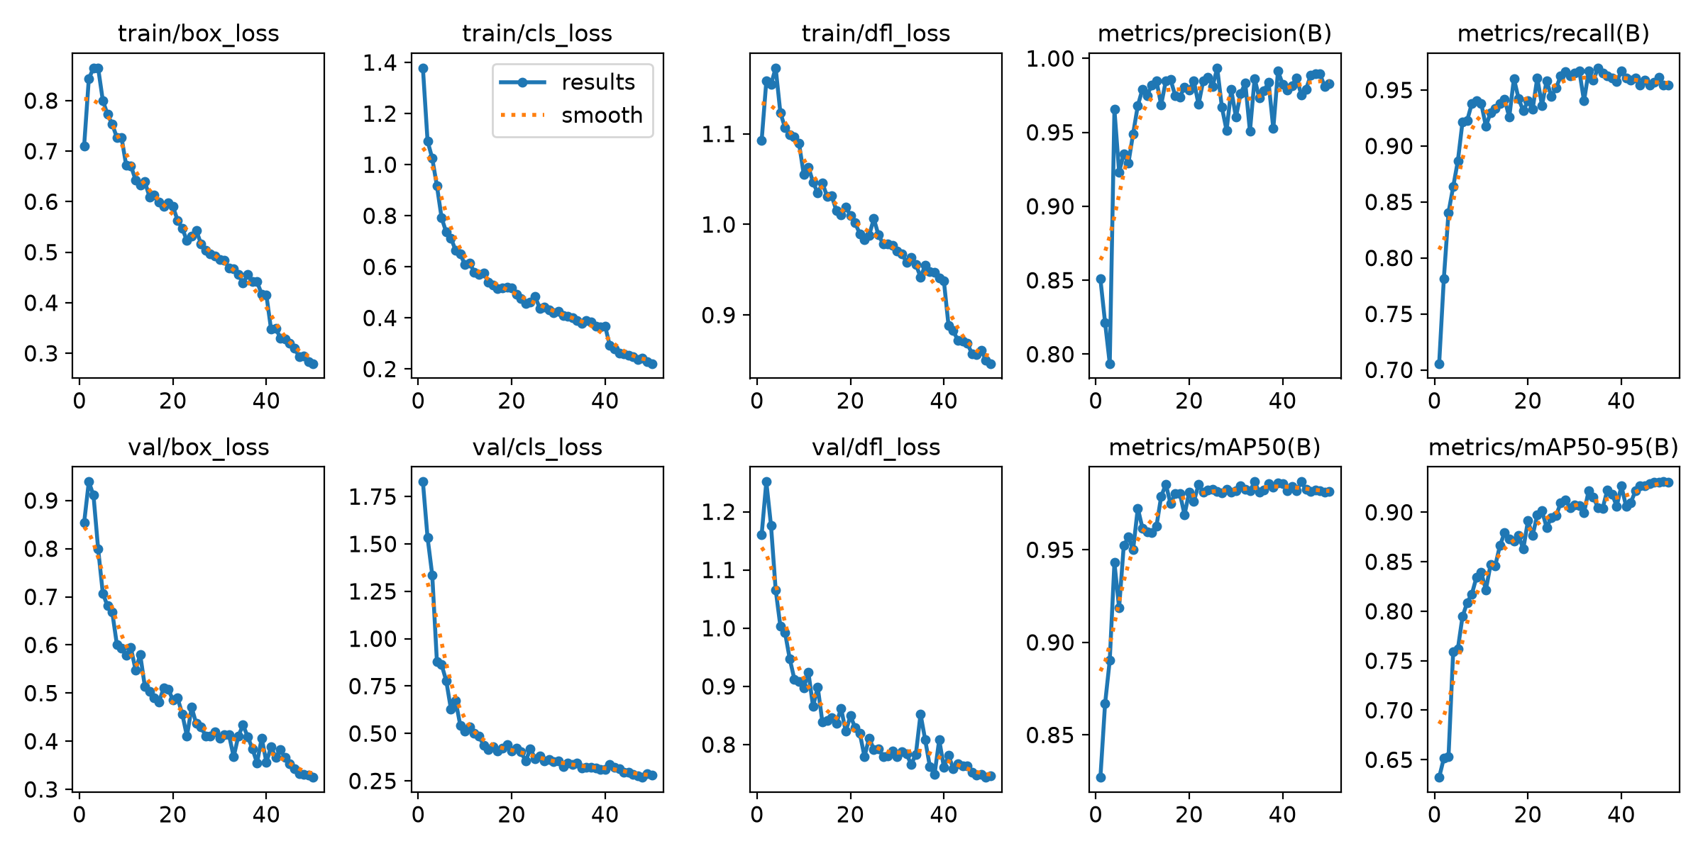
Box, classification, and DFL loss (train/val) alongside precision, recall, and mAP across all 50 training epochs, generated automatically by Ultralytics.
Figure G.2. Confusion Matrix (Validation Set)
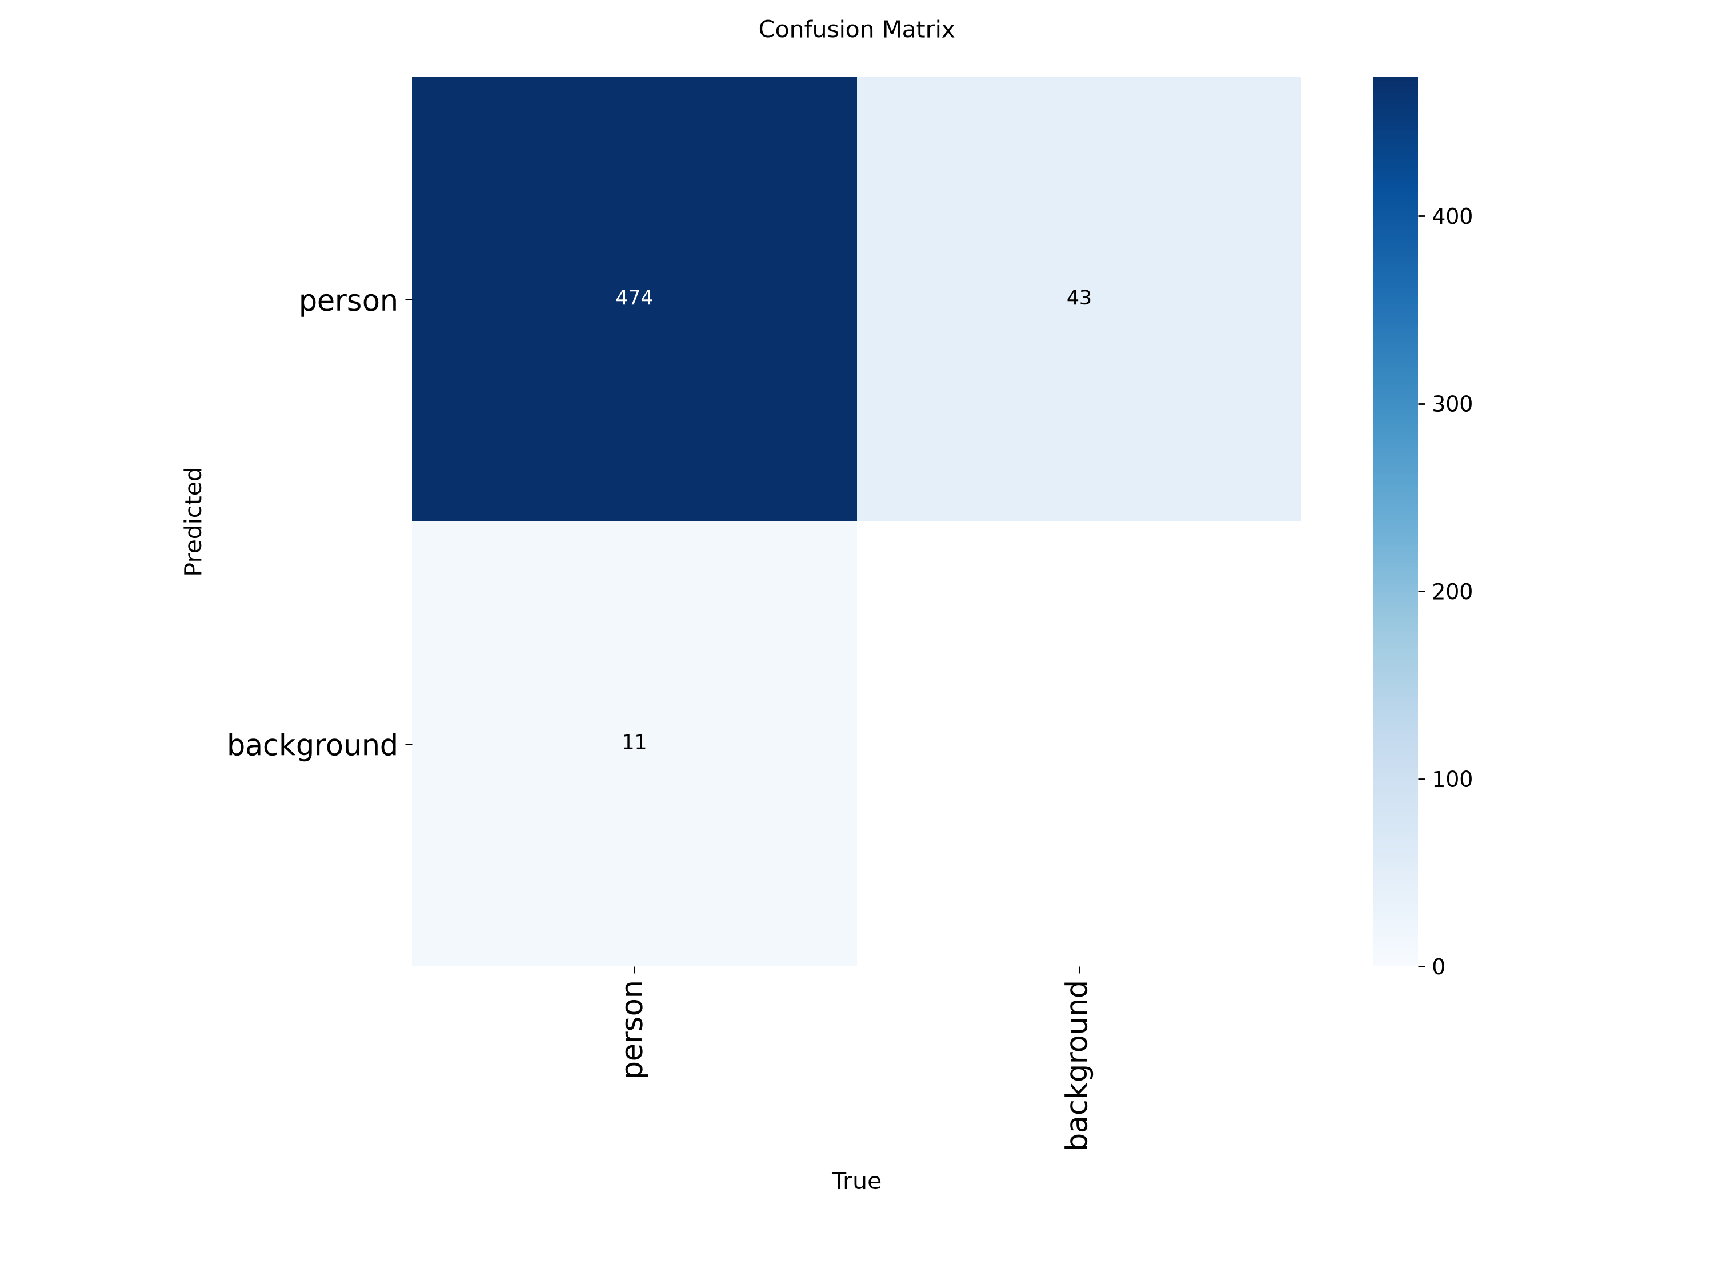
Person-class confusion matrix on the held-out validation set at the best checkpoint (epoch 49).

G.1.6 Model Performance (Applied, System-Level)
Beyond raw training metrics, the model's applied performance was evaluated as part of CAPHY's full detection pipeline during functional testing (see Appendix G.4 and Appendix G below for full records). Across 45 functional trials, the two-factor pipeline — of which YOLOv8-nano is the second, human-verification factor — achieved 88.9% accuracy, 100.0% precision, 85.7% recall, and a 92.3% F1-score, with zero false positives and all five false negatives occurring specifically under low-light conditions.

G.1.7 Detection Classes
The fine-tuned model is single-class: it detects only the person class. This is a deliberate design choice — CAPHY does not need to classify the type of non-human object causing motion (e.g., a cat versus a swaying tree); it only needs to confirm whether a human is present, since that confirmation is what gates every downstream alert.

G.2 Two-Factor Detection

G.2.1 Factor 1 — Motion Detection
The first factor is a lightweight, CPU-cheap motion trigger built on OpenCV, designed to run continuously without invoking the heavier YOLOv8-nano model on every frame. This keeps CAPHY responsive on repurposed hardware by reserving the expensive verification step for frames that actually contain motion. Implemented in detection/motion_detector.py.

OpenCV Motion Detection
Incoming camera frames are converted to grayscale and Gaussian-blurred before being compared against a running background model. Only frames where the cleaned motion mask's total contour area exceeds the configured minimum area are passed forward to Factor 2 for person verification, filtering out camera noise and negligible movement before any AI inference is triggered.

MOG2 Background Subtraction
CAPHY's implementation uses OpenCV's MOG2 (Mixture of Gaussians) adaptive background subtractor, specifically because MOG2 can mark shadows separately from real foreground motion (output value 127 for shadow vs. 255 for real motion); the system thresholds the mask to keep only the 255 values, discarding shadows before they are ever counted as motion. Morphological opening removes speckle noise and dilation reconnects nearby motion blobs before contour area is measured.
Parameter | Configured Value
Method | cv2.createBackgroundSubtractorMOG2(detectShadows=True)
MOG2 history | 500 frames
MOG2 variance threshold | 40
Gaussian blur kernel | 5×5
Shadow/foreground threshold | 200 (of 255)
Minimum motion area to trigger | 1,500 px²

CLAHE / Night Vision Processing
Contrast-Limited Adaptive Histogram Equalization (CLAHE) is applied to the lightness channel of the frame (in LAB color space) to enhance local contrast under low-light conditions, followed by a gamma brightness lift, before motion detection and person verification are attempted. Implemented in detection/night_vision.py, this enhancement runs automatically only when the frame's average brightness falls below a configured threshold — it does not needlessly process already well-lit frames — and corresponds to the system's Night Vision setting.
Parameter | Configured Value
CLAHE clip limit | 2.5
CLAHE tile grid size | 8 × 8
Low-light trigger threshold | Average brightness < 70 (0–255 scale)
Gamma brightness lift | 1.4
Auto mode | Enabled — enhancement applied only when frame is detected as low-light
While CLAHE improves detectability in dim conditions, it cannot fully compensate when insufficient visual information is captured by the camera sensor itself, which is the documented source of CAPHY's five low-light false negatives (TC008).

G.2.2 Factor 2 — Person Validation
Only frames flagged by Factor 1 as containing motion are passed to the fine-tuned YOLOv8-nano model described in G.1, implemented in detection/person_detector.py. This second factor exists specifically to eliminate false alarms from non-human motion (stray animals, swaying trees/plants, shadows) — the leading cause of alert fatigue in conventional motion-only security systems. Inference automatically runs on the GPU (CUDA) when available, falling back to CPU otherwise.

Person Confidence Threshold
The system accepts a YOLOv8-nano detection as a confirmed person at a confidence threshold of 0.50 (50%) or higher, using an inference image size of 640×640 and filtering for class ID 0 (person) only.

Frame-Skip Optimization
To reduce CPU/GPU load, YOLO inference does not run on every single motion-flagged frame; it runs every 8th frame (PERSON_EVERY_N = 8) while a person is present, reusing the most recent bounding boxes on the frames in between. This roughly preserves detection coverage while substantially reducing the computational cost of continuous inference.

Person Detection Process
Each sampled motion-flagged frame is passed through the fine-tuned YOLOv8-nano model. If the model returns a person-class detection at or above the 0.50 confidence threshold, the detection is confirmed as human and the frame's bounding box is passed forward for distance estimation and threat-tier classification (Section G.3). If no person-class detection meets the threshold, the event is discarded as non-human motion and no alert is generated — this two-factor gating (implemented in detection/two_factor.py) is the mechanism responsible for CAPHY's 100.0% precision and zero recorded false positives across 45 functional trials.

G.3 Threat-Level Logic
Implemented in detection/tier_engine.py.

G.3.1 Distance Calculation
Once a person is confirmed by Factor 2, CAPHY estimates the subject's distance from the camera using an inverse relationship with the height of the returned bounding box: closer subjects produce taller bounding boxes (and a smaller estimated distance), while farther subjects produce shorter bounding boxes (and a larger estimated distance).
Item | Value
Formula | distance (m) = DISTANCE_K ÷ bounding_box_height_px
DISTANCE_K constant | 1350.0 (calibrated for a 1080p camera frame height)
DISTANCE_K was empirically calibrated against the project's 1920×1080 camera setup — if camera resolution changes, this constant must be recalibrated, per the comment in config.py.

G.3.2 Threat-Tier Classification
Tier | Distance | Response (Unarmed)
Tier 1 | > 4.5 m | Snapshot + notification
Tier 2 | 2.5 m – 4.5 m | Snapshot + notification + 5-second video clip
Tier 3 | < 2.5 m | Snapshot + continuous video until subject exits + siren + notification (requires acknowledgment)

G.3.3 Smoothing
Raw per-frame distance estimates can fluctuate slightly from frame to frame even for a stationary subject, due to minor bounding-box jitter. CAPHY applies exponential moving-average smoothing (smoothing factor = 0.35, meaning each new reading contributes 35% of the updated estimate) before committing to a distance value, preventing a single noisy frame from triggering an incorrect tier.

G.3.4 Hysteresis
Testing without hysteresis measured 13 tier changes across 20 frames for a motionless person standing near the 4.5 m boundary, including spurious jumps to Tier 3 that would fire the siren at random. To prevent this rapid tier flapping, CAPHY applies a hysteresis margin of 0.12 (12%): a subject must cross a tier boundary by that margin before the system commits to escalating or de-escalating the threat tier, so a reading sitting exactly on the line stays at its current tier. The tier resets to neutral whenever motion clears (the person exits frame), so the next detected person starts classification from scratch.

G.3.5 Arming Behavior
In Armed Mode, all confirmed human detections — regardless of estimated distance — are escalated directly to the full Tier 3-equivalent response (snapshot + continuous recording + siren + a high-priority "ARMED" notification requiring acknowledgment), reflecting that any human presence while the system is armed represents a full-priority event. In Disarmed/normal monitoring mode, the standard distance-based Tier 1–3 classification and response table in G.3.2 applies.

G.4 Model Testing
The following results summarize the applied, system-level testing of the two-factor detection pipeline (motion detection + person validation) across the full functional test suite: nine scenarios (TC001–TC009), five trials each, 45 trials total. Full per-trial records are provided separately in the Detailed Functional Test Records appendix.

G.4.1 Confusion Matrix
 | Predicted: Person | Predicted: No Person
Actual: Person | TP = 30 | FN = 5
Actual: No Person | FP = 0 | TN = 10
All five false negatives occurred under the low-light test scenario (TC008); no false positives were recorded in any of the 45 trials.

G.4.2 Performance Metrics
Metric | Value | Formula
Accuracy | 88.9% | (TP + TN) / Total
Precision | 100.0% | TP / (TP + FP)
Recall | 85.7% | TP / (TP + FN)
F1-Score | 92.3% | 2 × (Precision × Recall) / (Precision + Recall)

G.4.3 Detection Examples
Figure G.3. Model Predictions on Validation Images
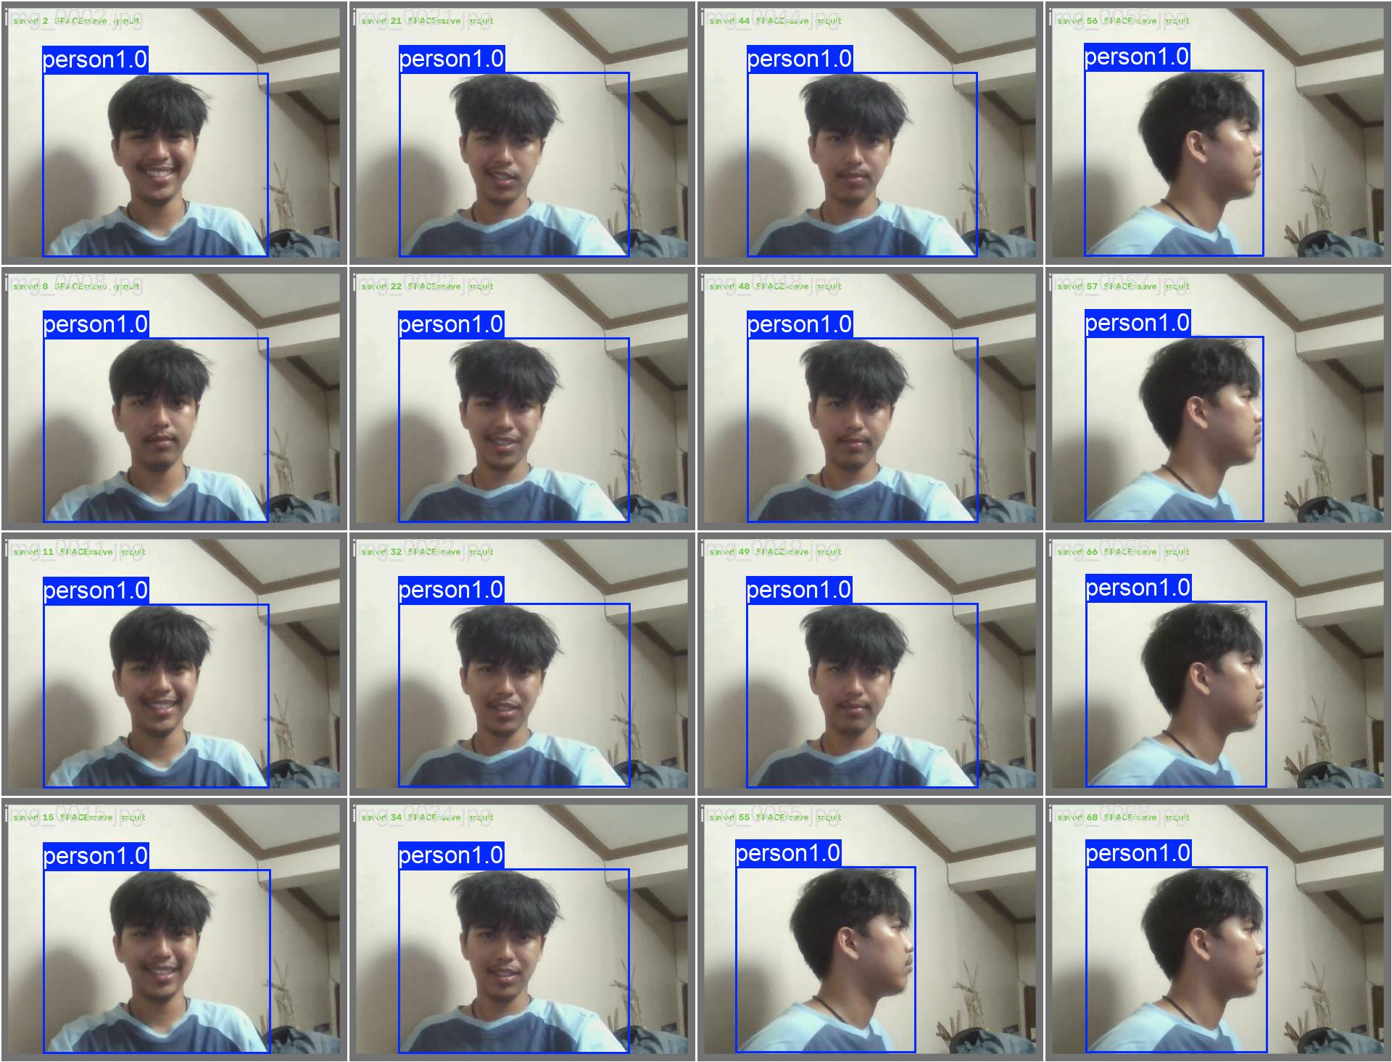
Actual YOLOv8-nano predictions (bounding boxes and confidence scores) on a held-out validation batch, generated automatically by Ultralytics during training.
[FILL IN — Optionally add 2–3 screenshots from your own live system (not the training run) showing: a real-time confirmed detection with tier label in the CAPHY dashboard, a correctly ignored non-human motion event, and a low-light missed-detection example (TC008) — these come from your actual running app, not the GitHub repo, so a screenshot is the only way to capture them.]

